SETH GREEN AND THE STUDIO BEHIND ROBOT CHICKEN LAUNCH “STOOPID BUDDY STOODIOS ANIMATIONS CAMP” ON VIMEO ON DEMAND

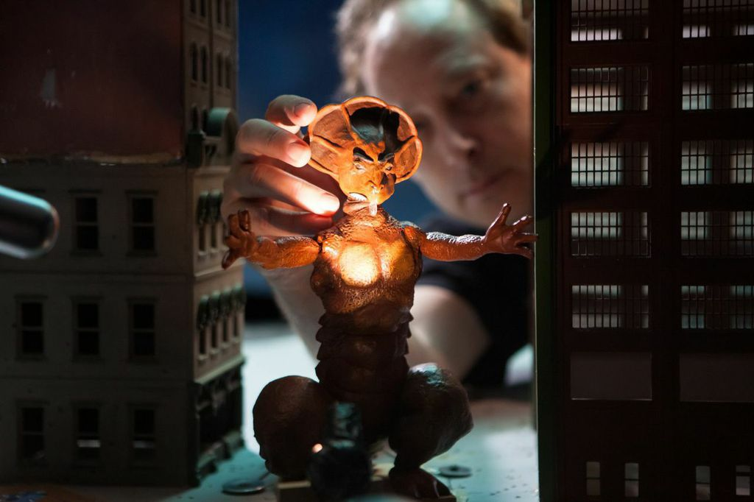

New York, NY – December 15 2014 – Today, Stoopid Buddy Stoodios, the studio behind the longest running stop-motion show on television, Robot Chicken, introduced “Stoopid Buddy Stoodios Animation Camp,” a first-of-its-kind stop-motion character animation course available now on Vimeo On Demand: https://vimeo.com/ondemand/animationclass.

Taught by Stoopid Buddy’s award-winning animation team, the two-hour course is the first animation educational service of its kind, providing hands-on training, tips and lectures designed to arm aspiring animators with the knowledge and tools needed to hone their specialized craft and become a successful professional. Topics covered include frame rates, basic physics, walks, performing with a character, and animating to dialogue.

The course is available for a $99.99 digital download or a $79.99 streaming 30-day rental.

The online stop-motion animation course consists of a series of classes that augment Stoopid Buddy Stoodios’ popular eight-week beginner and intermediate training courses held at the company’s Burbank, California studio.

About Vimeo

Vimeo® is the high-quality video platform for creators and their audiences. Vimeo’s mission is to empower and inspire people around the world to create, share, and discover videos. Vimeo enables creators to sell original films and series worldwide through Vimeo On Demand, its open self-distribution platform. Vimeo has more than 30 million registered members and reaches a global monthly audience of over 170 million people. Founded in 2004 and based in New York City, Vimeo, LLC is an operating business of IAC (NASDAQ: IACI).

About Stoopid Buddy Stoodios

Stoopid Buddy Stoodios is an artist-friendly collective that houses some of the finest talent in all of animation. Founded by partners Seth Green, John Harvatine IV, Matthew Senreich and Eric Towner, the company has a knack for creating unique visuals and telling character driven stories with an uncanny sensibility. Stoopid Buddy Stoodios is home to the longest running stop-motion show on television, Robot Chicken, as well as Mattel’s WWE Slam City, L/Studio’s Friendship All-Stars, MAD’s stop-motion Spy vs. Spy, among many others.

The company’s two-building campus and state-of-the-art facility located in Burbank, CA, makes it the largest studio specializing in stop-motion animation in California. The company’s work covers the animation gamut, ranging from charming hand-crafted animation all the way to high-end feature quality animation.

For more information, please visit www.leagueofbuddies.com

###

Media Contacts:

On Behalf of Stoopid Buddy Stoodios
Dennis Dembia / Alice Chung
P: 310.854.8114 / 310.854.8226
ddembia@rogersandcowan.com achung@rogersandcowan.com

For Seth Green
Brenda Feldman
P: 818.808.0000
FeldmanPR1@gmail.com

For Vimeo:
Jessica Casano-Antonellis
P: 212.524.7164
Jessica@vimeo.com

