HAL HARTLEY’S ‘NED RIFLE’ TO PREMIERE ON
VIMEO ON DEMAND IN SPRING 2015
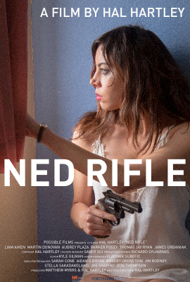
NEW YORK, December 3, 2014 - Vimeo has teamed up with celebrated indie stalwart Hal Hartley for the North American release of his latest feature NED RIFLE (https://vimeo.com/113407966), starring Liam Aiken and Aubrey Plaza, which recently bowed to acclaim at Toronto. The film will unspool on a day-and-date platform this spring through a limited exclusive window with Vimeo On Demand, then will expand via Hartley’s own successful digital storefront Possible Films (newly re-christened HalHartley.com) and other aggregated platforms. A limited theatrical five-city art-house launch, led by a run at New York City's IFC Center, will coincide with the VOD release.

“Hal Hartley is a legendary filmmaker and we are thrilled to have his latest piece premiere exclusively on Vimeo On Demand,” said Sam Toles, VP of Acquisitions and Business Development, Vimeo.

“One can never be independent enough,” says Hartley. “This is a real opportunity to take advantage of new business models, new marketing ideas and platforms, and ultimately, to effectively reach my audience in the most direct and successful way possible.” Hartley is repped by Stephen Gates and Sekka Scher at Evolution Entertainment.

ABOUT VIMEO
Vimeo® is the high-quality video platform for creators and their audiences. Vimeo’s mission is to empower and inspire people around the world to create, share, and discover videos. Vimeo enables creators to sell original films and series worldwide through Vimeo On Demand, its open self-distribution platform. Vimeo has more than 30 million registered members and reaches a global monthly audience of over 170 million people. Founded in 2004 and based in New York City, Vimeo, LLC is an operating business of IAC (NASDAQ: IACI).

Contacts:

Media Contact:
Sylvia Desrochers | Suzie Cornell
Big Time PR & Marketing
424-208-3496
Sylvia@bigtime-pr.com
Suzie@bigtime-pr.com

