ANNUAL “MYSTERY SCIENCE THEATER 3000” TURKEY DAY CELEBRATION COMES TO VIMEO WITH THREE NEWLY CLEARED EPISODES

Jungle Goddess, The Painted Hills and The Screaming Skull Added to the “Mystery Science Theater 3000” Collection Available Exclusively on Vimeo On Demand

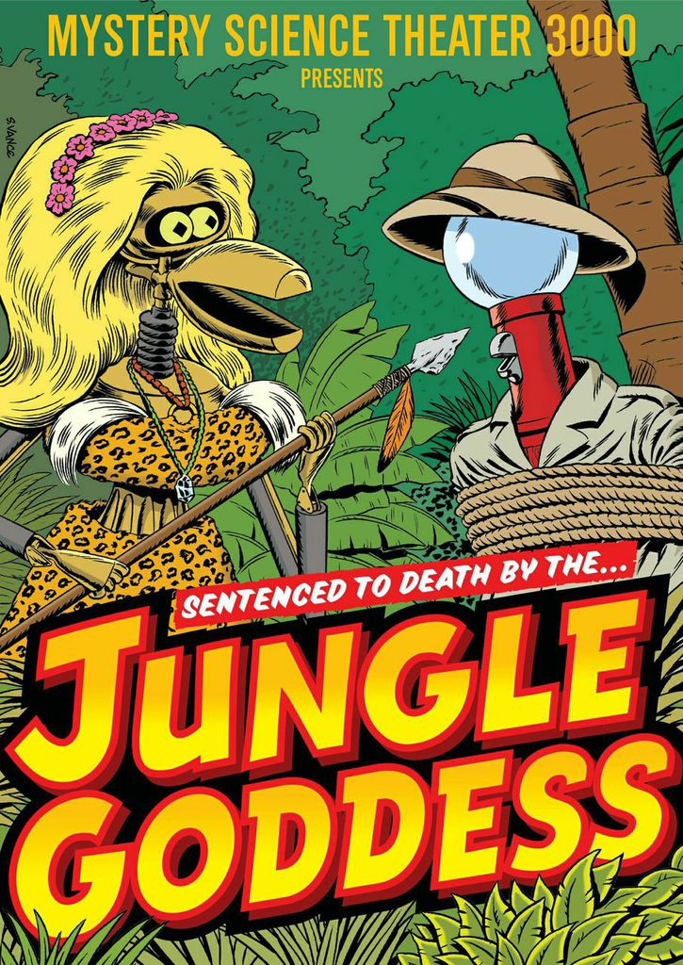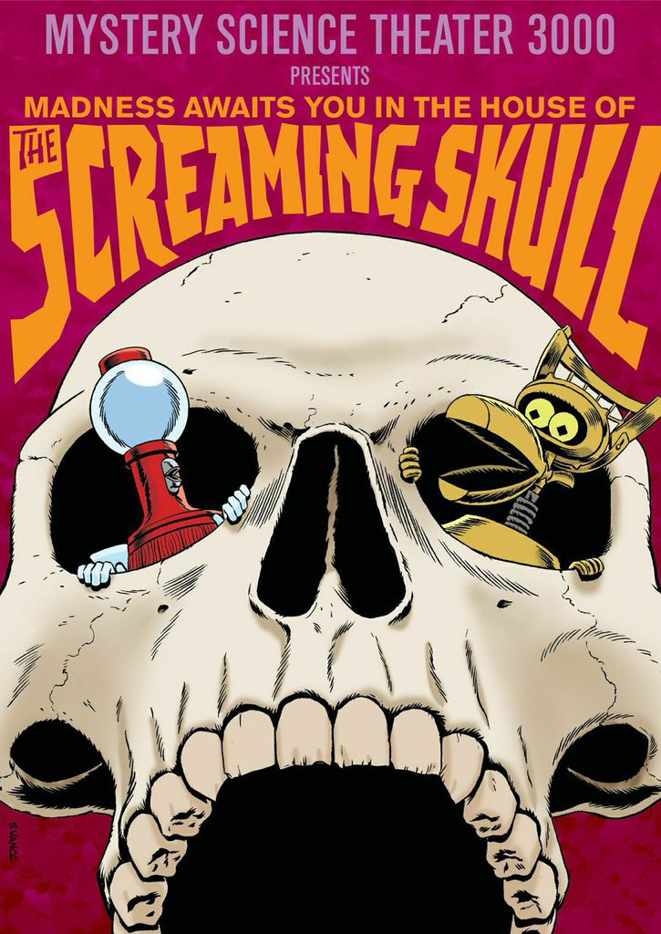

NEW YORK, November 25, 2014 – Just in time for Turkey Day, Vimeo today announced the release of three newly cleared episodes of cult comedy series Mystery Science Theater 3000 to Vimeo On Demand (https://vimeo.com/ondemand/mst3k).

The newly released episodes include:

- Jungle Goddess, the tale of two pilots in search of a missing heiress and her father’s reward money. They track her down in the African jungle where she is doing just fine, thank you.
- The Painted Hills, based on a novel about a kindly prospector who is murdered and his faithful pup takes on the perp.
- The Screaming Skull, wherein a neurotic woman is driven to distraction – if not destruction – by the ghost of her new husband’s previous wife.

The release expands upon Vimeo’s partnership with Shout! Factory launched earlier in the year, which gives fans of the beloved show the option to buy the entire collection for $300 (a savings of $500), buy individual titles for $9.99 or rent individual titles for $2.99 each. Fans who purchase the collection – now containing 83 episodes – will also receive any additional newly cleared episodes added between now and September 15, 2015. Anyone that previously purchased the MST3K Collection on Vimeo On Demand will automatically receive the newly cleared episodes.

As part of today’s announcement Vimeo and Shout! Factory have unveiled downloadmst3k.com, the website to rent and download MST3K episodes.

Launched in 1988 and running for 198 episodes before going off the air in 1999, Mystery Science Theater 3000 follows the motley crew of a human host and his two robot sidekicks aboard the Satellite of Love as they are forced to watch some of the most outrageously unfortunate B movies – all while providing laugh-out-loud commentary and cracking jokes.

About Vimeo
Vimeo® is the high-quality video platform for creators and their audiences. Vimeo’s mission is to empower and inspire people around the world to create, share, and discover videos. Vimeo enables creators to sell original films and series worldwide through Vimeo On Demand, its open self-distribution platform. Vimeo has more than 30 million registered members and reaches a global monthly audience of over 170 million people. Founded in 2004 and based in New York City, Vimeo, LLC is an operating business of IAC (NASDAQ: IACI).

###

MEDIA CONTACT:

Jessica Casano-Antonellis
Jessica@vimeo.com
212-524-7164

