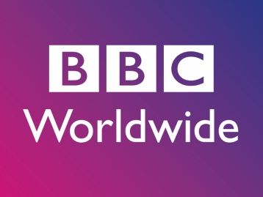
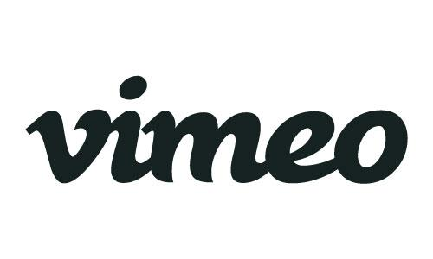

UK MEDIA POWERHOUSES ALL3MEDIA INTERNATIONAL AND BBC WORLDWIDE JOIN VIMEO’S GLOBAL MARKETPLACE

NEW YORK, NY (November 15, 2016) – Vimeo, home to the world’s leading video creators and hundreds of millions monthly viewers, announced content partnerships with two leading UK companies: independent distributor all3media International and BBC Worldwide, bringing a range of award-winning comedy, drama, and documentary titles to Vimeo’s transactional video on demand (TVOD) marketplace.

“Vimeo is thrilled to collaborate with all3media International and BBC Worldwide,” says Vimeo’s Head of Global Content Partnerships and Distribution, Sam Toles. “The partners each bring a unique array of content from UK’s finest creators that we’re excited to have on our platform for viewers around the world.”

The first slate of all3media International programming released on Vimeo includes all four seasons of Objective Productions’ award-winning “Fresh Meat,” the painfully amusing drama following six students through their university years, from acclaimed satirical and comedy writers Jesse Bain and Sam Armstrong (“The Thick of It,” “Peep Show”). “Fresh Meat” will be available on Vimeo worldwide (excluding UK) starting today.

Also making its debut on Vimeo from all3media International today will be all seven seasons of Company Pictures’ iconic youth series “Skins.” Winner of multiple awards and garnering wide critical and commercial acclaim, “Skins” tackles the highs and lows of growing up through the stories of friendship, ambition, drug culture, mental health, sex and relationships, all with an honesty and conviction seldom seen on screen. “Skins” will be available worldwide on Vimeo (excluding Australia), with multiple seasons available in other markets.

Paul Corney, SVP Global Digital Sales at all3media International, notes, “We’re very pleased to sign this deal with Vimeo in what we are expecting will be the start of a highly successful ongoing global collaboration. Vimeo has a strong presence around the world with a great brand that reaches consumers in all key markets – its team has a dynamic outlook on content delivery and we’re looking forward to working with them to bring more fantastic new shows to the Vimeo audience.”

On the BBC Worldwide side, music documentary “They Will Have To Kill US First,” and shortform series “Mission Selfie” and “Isms & Schisms” will debut on Vimeo tomorrow. “They Will Have To Kill US First,” a Mojo Music production, was selected for the SXSW and London Film Festivals and tells the compelling story of when music was banned in Northern Mali in 2012 following Jihadist control, forcing musicians into exile. The doc will be available worldwide on Vimeo (except for the US and France). “Mission Selfie,” which has previously only run on BBC Three in the UK, features social media stars Ben Brown and Steve Booker as they travel the globe on a quest to take the ultimate “selfie” in this exciting shortform adventure series. A Narrative production for BBC Worldwide, “Mission Selfie” will be available worldwide on Vimeo. “Isms & Schisms” will have a global, all-platform premiere on Vimeo. A Burning Bright production for BBC Worldwide, this fast-moving short form series offers a fun and irreverent study of politics and ideology around the world, with exciting young journalist and writer Owen Jones explaining the –isms and issues that concern us all.
Stuart Wettenhall, Digital Partnerships at BBC Worldwide said “We’re thrilled to be partnering with Vimeo. We think our launch titles serve the adventurous spirit of Vimeo’s dedicated audience, continuing the BBC’s tradition of premium storytelling. We look forward to growing our partnership with Vimeo over the coming year.”

About all3media International
all3media International distributes popular, award-winning TV programmes to over 1000 broadcasters and media platforms around the world. The company has been celebrated for producing, marketing and distributing quality, ground-breaking and pioneering shows to global audience – consistently topping the Broadcast and Televisual annual Indies Surveys and we have been awarded the Queen’s Award for Enterprise in recognition of our growth – twice.

Its catalogue contains over 7,000 hours of content across all genres, with a focus on drama, comedy, factual, entertainment and formats. As well as Britain’s top-selling series “Midsomer Murders,” our lead dramas include “The Missing,” “Indian Summers,” “Foyle’s War,” “Skins,” “Miss Fisher’s Murder Mysteries,” and “Hinterland.” Factual, entertainment and format bestsellers include “Gogglebox,” “Undercover Boss,” “The Gadget Show,” “The Cube,” “The Only Way is Essex,” and “The Million Second Quiz.”

About BBC Worldwide
BBC Worldwide is the main commercial arm and a wholly owned subsidiary of the British Broadcasting Corporation (BBC). Its vision is to build the BBC’s brands, audiences, commercial returns and reputation across the world. This is achieved through investing in, commercialising and showcasing content from the BBC around the world, in a way that is consistent with BBC standards and values. The business also champions British creativity globally.

In 2015/16, BBC Worldwide generated headline profits of £133.8m and headline sales of £1,029.4m and returned £222.2m to the BBC. For more detailed performance information please see our

Annual Review webpage: www.bbcworldwide.com/annual-review
www.bbcworldwide.com
twitter.com/bbcwpress

About Vimeo
Vimeo is home to the world’s most imaginative video creators and the hundreds of millions of viewers who love them. Vimeo empowers over 50 million creators with the tools they need to host, share and sell videos in the highest quality possible. Also a leading online entertainment destination, Vimeo now reaches viewers in over 150 countries who can watch content anytime, on nearly every Internet-connected device. Founded in 2004 and based in New York City, Vimeo, Inc. is an operating business of IAC (NASDAQ: IAC).

all3media International Contact
Rachel Glaister | rachel.glaister@all3media.com

BBC Worldwide Contact
Carrie Jones | Carrie.Jones@bbc.com

Vimeo Contact
Caitlin Hughes | caitinh@vimeo.com

