VIMEO ORIGINAL SERIES HIGH MAINTENANCE
PREMIERES GLOBALLY TODAY, NOVEMBER 11th

Acclaimed Series Returns with New Episodes on Vimeo On Demand

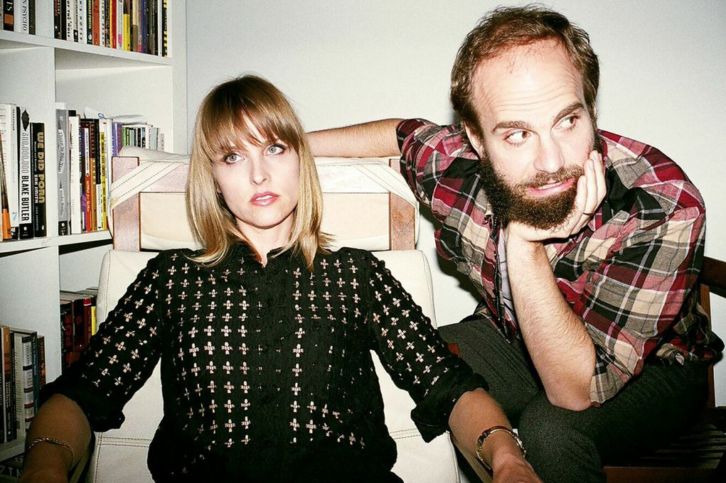

(Creators Katja Blichfeld & Ben Sinclair / Photo by Paul Kwiatkowski)

(November 11, 2014 | New York, NY) Today, Vimeo premieres a new round of episodes of married couple Katja Blichfeld and Ben Sinclair’s heralded series High Maintenance. Three new episodes are available now at HighMaintenance.tv, followed by another set of three in early 2015.

High Maintenance centers around a cannabis dealer known simply as "The Guy" (Sinclair) who slips in and out of the lives of his clients – an eclectic array of Brooklynites, ranging from a harried personal assistant buying weed for her boss to a misunderstood asexual magician.

The series marks Vimeo’s first foray into original programming with the six episodes launching exclusively on Vimeo On Demand. High Maintenance previously released thirteen episodes on Vimeo to the acclaim of The New Yorker, The New York Times, The Guardian and Entertainment Weekly, among others.

“Vimeo is dedicated to inspiring creators to share, publish and sell quality content worldwide,” said Kerry Trainor, Vimeo CEO. “Ben and Katja are amazing storytellers-- that’s why we invested in them and we’re excited to celebrate the new episodes released today with fans worldwide.”

“Vimeo has given us the opportunity of a lifetime, said Katja Blichfeld. “It is a truly enviable position to be in as a creative professional,” added Sinclair. “It was incredible to have such a personal project supported by such a forward-thinking entity.”

The new episodes are available globally and have subtitles translated to German, French, Brazilian Portuguese, Spanish, Italian, Hindi, and Japanese, enabling High Maintenance to reach a wider audience than ever before.

Episodes are available individually for $1.99/€1.59 each or $7.99/€6.49 for the entire series (including the three launching in January).

Blichfeld and Sinclair are represented by Gregory McKnight of CAA, Russell Gregory of Regarding Entertainment, and Kim Jaime of Jackoway Tyerman.

About Vimeo
Vimeo® is the high-quality video platform for creators and their audiences. Vimeo’s mission is to empower and inspire people around the world to create, share, and discover videos. Vimeo enables creators to sell original films and series worldwide through Vimeo On Demand, its open self-distribution platform. Vimeo has more than 30 million registered members and reaches a global monthly audience of over 170 million people. Founded in 2004 and based in New York City, Vimeo, LLC is an operating business of IAC (NASDAQ: IACI).

###

Media Contacts

Vimeo | Jessica Casano-Antonellis
Jessica@vimeo.com

Brigade Marketing | Adam Kersh
Adam@BrigadeMarketing.com

