**/Users/hughesc/Desktop/vimeo_logo_blue_on_white.ai**

**Vimeo Announces November’s Staff Pick Premieres Slate**

**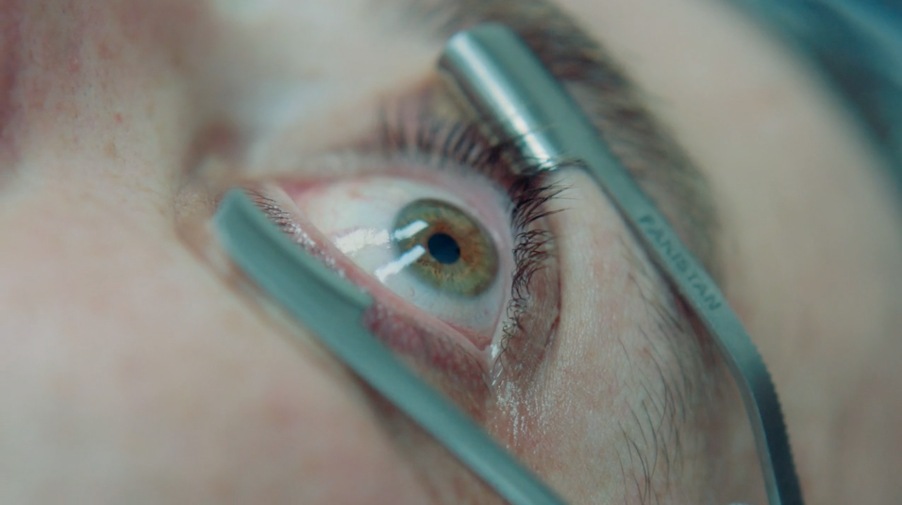**

(Calvin Reeder’s “The Procedure)

**This Month’s Slate Includes Josh and Benny Safdie’s “The Incident” and Sundance 2016 Short Film Jury Award-Winner “The Procedure”**

**(New York, NY | November 9, 2016)** Vimeo announces their November slate of Staff Pick Premieres, a different one debuting each Wednesday; Vimeo’s popular Staff Pick channel is curated by a four-person team that highlights the best short-form content on the platform. The Staff Pick laurel emblazons each selected short, which has often screened at a high profile film festival, and the short can get between 50,000 and 200,000 views in one day. This month’s roster includes “The Incident” by celebrated filmmakers Josh and Benny Safdie (HEAVEN KNOWS WHAT) and Sundance 2016 Short Film Jury Award-winner “The Procedure,” a delightfully bizarre scatological surprise.

Launching with last month’s “Curmudgeons,” directed and produced by Danny Devito, Staff Pick Premieres are weekly global online premieres of a pre-selected Staff Pick. Vimeo supports each Staff Pick Premiere via on and off-site promotion, including editorial coverage and marketing support. In addition, Staff Pick Premieres have an open submission process for any film that has played at an Oscar-qualifying event within the last 24 months.

**November’s schedule is as follows:**

**“Burnout” – Documentary, Premiered November 2nd (Dir. Miguel Lopez Valdivia)**

Synopsis: "Burnout" is the portrait of a paramedic and his relationship with death. A duel between the deep pleasure that gives him the adrenaline when he turns on the siren, and the emotional weariness from being the witness of countless tragedies.

About the Filmmaker: Miguel Lopez Valdivia graduated from Universidad Iberoamericana in Mexico City, a school where filmmakers such as Alejandro González Iñárritu, Guillermo Arriaga, Carlos Carrera and Michel Franco among many others attended. "Burnout", his latest short film, was part of the official selection at Sheffield Doc/Fest 2016. He's currently developing his first feature.

**“It’s a Date” – Animation, Premieres November 9th (Dir. Zachary Zezima)**

Synopsis: Based on a true story, this 2D animated narrative from Zachary Zezima details the strange and absurd qualities that you try to keep to yourself during a first date.

About the Filmmaker: [Zachary Zezima](http://www.zacharyzezima.com/) is an animator and illustrator from New York, currently based in Los Angeles. He received his MFA in Experimental Animation from CalArts and is a co-founder of [Circle Line Projects](https://vimeo.com/circlelineprojects). This is his second Staff Pick.

**“The First Men” – Narrative, Premieres November 16th (Dir. Benjamin Kegan)**

Synopsis: An overextended teacher bumps into a troubled student while at the mall with her mom. Based on the Pushcart Prize winning short story by Stacey Richter.

About the Filmmaker: Benjamin Kegan is a New York based filmmaker with an MFA in film from Columbia University. Ben’s previous short films and documentaries have screened at several international film festivals including, SXSW, TriBeCa, BFI London.

**“The Incident” – Narrative, Premieres November 23rd (Dir. Josh and Benny Safdie)**

Synopsis: Filmmaker James Toback recounts his bouts with literary lion, Norman Mailer in this NYC-based film.

About the Filmmakers: Festival darling filmmakers Josh and Benny Safdie have a written and directed an acclaimed roster of films HEAVEN KNOWS WHAT, LENNY COOKE, DADDY LONGLEGS, and THE PLEASURE OF BEING ROBBED; they are currently in post-production on GOOD TIME, starring Robert Pattinson and Jennifer Jason Leigh. Their short “The Black Balloon” was a Vimeo Staff Pick.

**“The Procedure” – Comedy, Premieres November 30th (Dir. Calvin Reeder)**

Synopsis: A surprise medical procedure comes with rather unexpected, scatological results

About the Filmmakers: Calvin Reeder began his film career while employed as a construction worker in Seattle, Washington. Since then, his bizarre and unsettling films have earned him many awards, including the Short Film Jury Award in U.S Fiction for “The Procedure” at Sundance 2016.

Last month, Vimeo also added new layers to their curation; in addition to Staff Pick Premieres, they are also including a roundup of Best of the Month and Best of the Year shorts. October 2016’s Best of the Month honored adventure doc “China: A Skier’s Journey” by Jordan Manley, animated anatomical exploration “Private Parts” by Anna Ginsburg, harrowing documentary/fiction hybrid “In the Hollow” by Austin Bunn, surreal dance experience “Jamie XX” by Romain-Gavras, the picturesque skateboarding-in-Spain film “Tinto de Verano” by New Balance Numeric, Sundance 2016 Narrative Short Jury Award-winner “Pink Grapefruit,” and SXSW 2016 Documentary Short Award-winner “These C\*cksucking Tears.” October’s Best of the Month can all be watched [here](https://vimeo.com/channels/1154648) and [here](https://vimeo.com/channels/1154648/page:2).

Filmmakers interested in having their work considered for a Staff Pick premiere can email [premieres@vimeo.com](mailto:premieres@vimeo.com) for more information.

**About Vimeo**

Vimeo is home to the world’s most imaginative video creators and the hundreds of millions of viewers who love them. Vimeo empowers over 50 million creators with the tools they need to host, share and sell videos in the highest quality possible. Also a leading online entertainment destination, Vimeo now reaches viewers in over 150 countries who can watch content anytime, on nearly every Internet-connected device. Founded in 2004 and based in New York City, Vimeo, Inc. is an operating business of IAC (NASDAQ: IAC).

**Vimeo Contact**

Caitlin Hughes | [CaitlinH@vimeo.com](mailto:CaitlinH@vimeo.com)