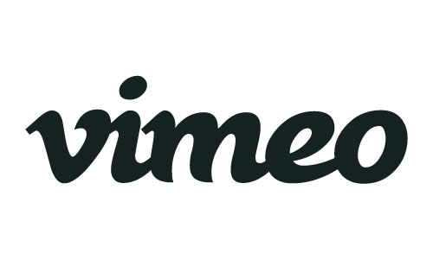
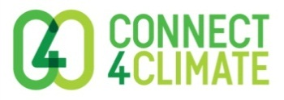

PRESS RELEASE
Film a #Day4Climate Action on November 29
WASHINGTON, October 29, 2015 – November 29 is the day of the Global Climate March. Connect4Climate, the global partnership program of the World Bank Group, the online platform Vimeo, and partners have joined forces to challenge citizens around the world to film their climate actions on that day, one month from today.
Dedicated to driving climate action around the world, the 24-hour Film a #Day4Climate Action challenge (connect4climate.org/competition/day4climate) asks aspiring filmmakers and citizens worldwide to document climate actions, solutions and conversations happening on a day dedicated to global climate mobilization.

On November 29, a day before the UNFCCC 21st Conference of the Parties (COP21) meeting starts in Paris with a gathering of global leaders, citizens all around the world will march for an ambitious outcome in Paris. COP21 is expected to adopt a binding agreement on the long-term reduction of greenhouse gas emissions.
As part of Connect4Climate’s Film4Climate Initiative, Film a #Day4Climate Action invites people globally to share their story from November 29 on what we should do to prevent dangerous climate change and save our planet.
The stories all need to be filmed and edited down to no more than 3 minutes in 24 hrs and submitted on the Vimeo’s group channel: Film a #Day4Climate Action – 29 November 2015 (https://vimeo.com/groups/day4climate), by the next day.
“Video is a powerful way for people to document activism and share their message with others. We’re excited to support Connect4Climate in their efforts to raise awareness for the steps we need to take to address climate change around the world,” said Vimeo’s Community Director, Darnell Witt.
Submitted video messages will be featured during the Youth Day at COP21 and at events across the city. The videos will also be brought together in a documentary telling the story of how citizens around the world showed their support for climate action. A celebrated editor and filmmaker will lead this effort for a launch at the World Bank Group in 2016.
“Telling stories in a way which allows others to experience a world, which they never would have otherwise seen, changes people. It has the power to change their perspectives, opinions and hearts. This is why film is such a powerful tool to encourage climate action.” -Lucia Grenna, Program Manager, Connect4Climate
Why now?
Just one day before the crucial climate negotiations in Paris (COP21) begin, coinciding with the Global Climate March - a decisive call for bold actions on climate change, this challenge represents an opportunity for people to come together through the power of video and share their messages, pledges and solutions for climate change. Everyone, everywhere, united to to build a resilient clean future!
Connect4Climate aims to raise global awareness about climate change in line with the World Bank’s mission to end extreme poverty within a generation and boost shared prosperity. As World Bank Group President Jim Yong Kim said, “We will never end poverty if we don’t tackle climate change.”
To plan ahead please visit: connect4climate.org/competition/day4climate
See the trailer here: https://vimeo.com/141448890
About Connect4Climate
Connect4Climate is a campaign, a coalition and a community dedicated to driving global action on climate change, connecting and amplifying climate initiatives and activities, and creating social currency and political capital for climate action. It works with more than 180 partner organizations around the world, and is funded by the World Bank, the Italian Ministry of the Environment and the Global Environment Facility.
About Vimeo
Vimeo’s mission is to empower creators to make, share and sell amazing videos directly to viewers worldwide, in the highest quality possible and with no interruptive advertising. Vimeo is home to the world’s leading video creators and the hundreds of millions of viewers who love them. Founded in 2004 and based in New York City, Vimeo, LLC is an operating business of IAC (NASDAQ: IACI).
MEDIA CONTACT:
Lucia Grenna
Email: lgrenna@worldbankgroup.org

