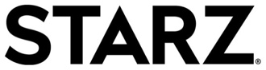
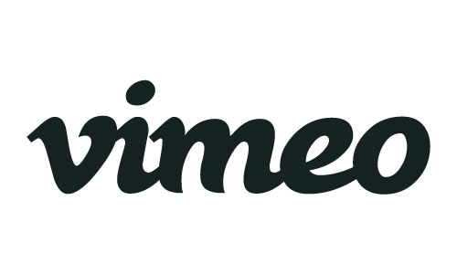

VIMEO LAUNCHES GLOBAL TELEVISION STORE FROM MIPCOM

AND ANNOUNCES STARZ AS LATEST PARTNER

Adds Hit STARZ Original Series Programming Ash vs Evil Dead, Black Sails and The Girlfriend Experience to Vimeo; Bolster Roster of Lionsgate Titles Licensed in U.S. and over 150 Countries around the World

Cannes/MIPCOM (October 18, 2016) – Today at the MIPCOM 2016 Global Market, Vimeo officially launched its new Global television storefront (vimeo.com/tvstore) in partnership with Lionsgate, the first major Hollywood studio to provide content for the new worldwide venture, including the hit television series Orange is the New Black, Casual, The Royals, Mad Men, and Weeds. Vimeo also announced Starz as the latest partner to license its acclaimed programming. In the coming weeks, Starz will bring its
STARZ Original limited series “The Girlfriend Experience,” horror-comedy series “Ash vs Evil Dead” and Emmy® Award-winning drama “Black Sails” to Vimeo’s ground-breaking global television store.

“As audiences across the globe continue to shift towards online viewing, Vimeo is taking a leadership role, establishing our On Demand storefront as the world’s first transactional service to offer premium television on a truly global basis” said Sam Toles, Senior Vice President, Programming. “We’re truly excited to be partnering with Lionsgate and now Starz to offer their content and today’s launch marks a huge expansion for our offering of premium programming.”

“Vimeo is undoubtedly one of the most cutting-edge online video platforms and Starz is very pleased to join Lionsgate in agreeing to provide content to Vimeo’s storefront. With this agreement, Starz will make available for purchase three of its most powerful and compelling STARZ Original series for consumers around the world,” said Jeffrey Hirsch, Chief Operating Officer at Starz.

The storefront was unveiled today at MIPCOM ceremonies led by Lionsgate President of Worldwide Television & Digital Distribution Jim Packer and Vimeo's Senior Vice President, Programming Sam Toles.

Available now, fans can access virtually the entire Lionsgate catalog of television series led by the blockbuster Orange is the New Black, the Golden Globe®-nominated dramedy Casual, the hit series The Royals, the iconic Emmy® Award-winning drama Mad Men and other catalog titles including Weeds, Nurse Jackie, Boss, Blue Mountain State and Manhattan.

The service is one of the first to deliver high-end premium scripted U.S. content to consumers in over 150 countries around the world at the same time.

About Vimeo
Vimeo is home to the world’s most imaginative video creators and the hundreds of millions of viewers who love them. Vimeo empowers over 50 million creators with the tools they need to host, share and sell videos in the highest quality possible. Also a leading online entertainment destination, Vimeo now reaches viewers in over 150 countries who can watch content anytime, on nearly every Internet-connected device. Founded in 2004 and based in New York City, Vimeo, Inc. is an operating business of IAC (NASDAQ: IAC).

About Starz
Starz (NASDAQ: STRZA, STRZB) is a leading integrated global media and entertainment company with operating units that provide premium subscription video programming on domestic U.S. pay television networks (Starz Networks) and global content distribution (Starz Distribution), www.starz.com. The Starz Networks operating unit is home to the flagship STARZ® brand with 24.2 million subscribers in the United States as of June 30, 2016, with the STARZ ENCORESM network at 31.8 million subscribers. Through STARZ, the company provides high quality, entertaining premium subscription video programming with 17 premium pay TV channels and associated on-demand and online services. STARZ is sold through U.S. multichannel video distributors, including cable operators, satellite television providers, telecommunications companies, and other online and digital platforms. Starz offers subscribers more than 5,000 distinct premium television episodes and feature films every year and up to 1,500 every month, including STARZ Original series, first-run movies and other popular movie and television programming. The Starz Distribution operating unit is home to the Anchor Bay Entertainment, Starz Digital, and Starz Worldwide Distribution divisions. In addition to STARZ Original series, Starz Distribution develops, produces and acquires movies, television and other entertainment content for worldwide home video, digital, and television licensing and sales.

Vimeo Contact:

Jessica Casano-Antonellis | Jessica@vimeo.com

Starz Contact

Eric W. Becker | eric.becker@starz.com

