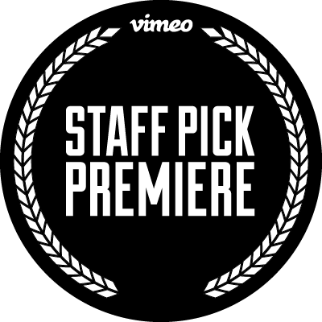
INTRODUCING VIMEO ‘STAFF PICK’ PREMIERES

Vimeo’s Flagship Staff Pick Channel Re-Launched as Year-Round Online Film Festival with Weekly Premieres and New Staff Pick Laurels

First-Ever Vimeo Staff Pick Premiere “Curmudgeons” from Director Danny DeVito
Bows to Global Audiences Today

NEW YORK (October 5, 2016) – Vimeo, home to the world’s most talented filmmakers and hundreds of millions of monthly viewers, today unveiled a new initiative extending its flagship Staff Pick channel into a year-long online film festival — stacked with new laurels honoring films selected as Best of the Month and Year, plus weekly premieres. Celebrating the best films on Vimeo since 2008, the Staff Picks Channel currently features over 10,000 film masterpieces handpicked by Vimeo’s in-house curation team for global audiences to discover and enjoy.

“The Vimeo Staff Pick channel represents the most progressive and imaginative filmmaking direct from our community of world class filmmakers,” said Peter Gerard, General Manager, Vimeo. “The iconic Staff Pick laurel has helped launched the careers of many filmmakers coming up through the Vimeo platform and we’re excited to continue to honor and elevate our Staff Picked filmmakers with two new levels of prestige, while also making the channel a must-watch for audiences tuning in weekly to the new Premieres programming.”

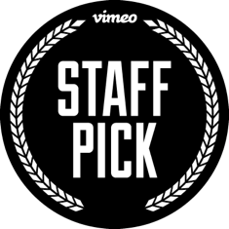
Vimeo Staff Pick Laurels:

Staff Pick - the eponymous and sought-after laurel of the Vimeo Staff Pick is not going anywhere. Vimeo’s in-house curation team will continue to scour Vimeo for the very best of online video covering comedy, drama, animation, documentary, action sports, adventure and music videos. While there is no set number of Staff Picks awarded throughout the year, the Vimeo curation team awards around 1,000 videos with the Staff Pick laurel annually.
Best of the Month - Each month, an hour’s worth of films and videos across a variety of genres are selected from that month’s pool of Staff Picks to receive the ‘Best of the Month’ laurel. There will be roughly 120 films selected per year creating 12 hours of online programming not to be missed.

Best of the Year - At the end of each calendar year, Vimeo curation will appoint ‘Best of the Year’ winners from its monthly Best-of pool in each of its core categories. In addition to receiving the ultimate Staff Pick laurel, filmmakers will receive dedicated marketing and promotional support for their winning film.

As part of the initiative, Vimeo is also introducing Staff Pick Premieres, a weekly global online film premiere of a pre-selected Staff Pick. Vimeo will support the film through both on and off-site promotion, including editorial coverage and marketing support. Staff Pick Premieres are selected by Vimeo’s in-house curation team, but will also have an open submission process for any film that has played in competition at an Oscar-qualifying event within the last 24 months. Qualifying filmmakers interested in having their work considered for a Staff Pick premiere can email premieres@vimeo.com for more information.

The first Vimeo Staff Pick Premiere is the short film Curmudgeons from director Danny DeVito now streaming on vimeo.com/Curmudgeons.

Sam Morrill, Head Curator for Vimeo’s Staff Picks adds, “We’re incredibly excited and honored to share Danny’s film with the world as our first-ever Vimeo Staff Pick Premiere. A family affair both on-screen and off, Curmudgeons’ colorful characters and colorful language had us laughing and crying the whole way through.”

Making its offline debut earlier this year at the Tribeca Film Festival, the short is a family affair -- Curmudgeons is directed and produced by Danny DeVito, alongside his co-producers, and children, Lucy and Jake DeVito. It tells how the best part of getting old is no longer caring what anybody thinks and Ralph Pajovic (the late DAVID MARGULIES) is no exception. At 80 years old and in assisted living, Ralph is involved in a relationship that makes his family anxious. On a crisp, Winter day, his unlucky-in-love granddaughter (LUCY DEVITO) comes for what seems like an ordinary audience with her curmudgeonly grandfather, but Ralph can’t possibly predict the surprise she has in store for him.

Other Upcoming Vimeo Staff Pick Premieres include:
- Wednesday, October 12 -- These C*cksucking Tears from Dan Taberski (SXSW 2016)
- Wednesday, October 19 – Partners from Joey Ally (Sundance 2016)
- Wednesday, October 26 -- Night of the Slasher from Shant Hamassian (SXSW 2016)
- Wednesday, November 2 -- Burnout from Miguel López Valdivia (Sheffield Doc/Fest 2016)

For more information visit Vimeo.com/StaffPicks.

--
About Vimeo
Vimeo’s mission is to empower creators to make, share and sell amazing videos directly to viewers worldwide, in the highest quality possible with no interruptive advertising. Vimeo is home to the world’s leading video creators and the hundreds of millions of viewers who love them. Founded in 2004 and based in New York City, Vimeo, Inc. is an operating business of IAC (NASDAQ: IAC).

Vimeo Contact:
Jessica Casano-Antonellis | Jessica@vimeo.com

For Danny Devito
Stan Rosenfield | Stan@sra-pr.com

