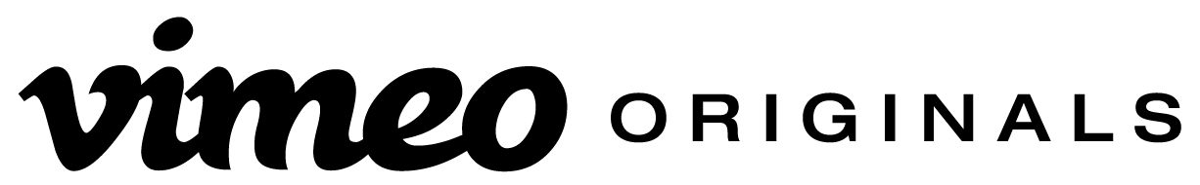
VIMEO EXPANDS EMMY®-NOMINATED ORIGINAL PROGRAMMING
WITH THREE NEW TITLES
Slate Includes Feature Length Doc from World Renowned Artist Marina Abramovic, Comedy Special from South African Comic Loyiso Gola, and Comedy Miniseries from John Early, Kate Berlant and Andrew DeYoung.

NEW YORK (September 22, 2016) – Continuing to invest in programming you won’t find anywhere else, Vimeo today announced its next slate of Originals, which includes: Vimeo’s first Latin American film and next feature-length documentary from one of the world’s most celebrated artists, Marina Abramovic in Brazil: The Space in Between; a comedy special from Emmy®-Nominated South African comic Loyiso Gola; and a new mini comedy series, 555, from rising comedians John Early (Search Party) and Kate Berlant (Characters). All three titles are part of Vimeo’s Share the Screen program – empowering female filmmakers through all stages of video production – and will premiere to audiences worldwide exclusively on Vimeo.

“Vimeo programming presents a surprising, fresh and uniquely global perspective directly from our community of world class filmmakers,” said Sam Toles, Head of Global Content Acquisition and Distribution. “These diverse comedy, documentary and internationally-focused projects led by strong female teams and voices are exciting additions to our Share the Screen initiative and critically acclaimed Original programming.”

New Vimeo Original programming includes:

Marina Abramovic in Brazil: The Space in Between (October, 2016)
Marina Abramovic travels through Brazil, in search of personal healing and artistic inspiration, experiencing sacred rituals and revealing her creative process. The route is comprised of poignant encounters with healers and sages from the Brazilian countryside, exploring the limits between art and spirituality. This external trip triggers in Marina a profound introspective journey through memories, pain and past experiences. A mixture between road movie and spiritual thriller, the documentary brings an unprecedented approach of the intimate creative process of one of the most important artists of our time.

Marina Abramovic in Brazil: The Space in Between is Vimeo’s first Original film from Latin America and comes to Vimeo from Elo Company. The film is produced by Jasmin Pinho and Minom Pinho, and is directed by Marco Del Fiol.

Loyiso Gola: Live in New York (November, 2016)
Two-time Emmy-nominated comedian Loyiso Gola brings his frank and outspoken comedy to the U.S. from South Africa, where he has been breaking taboos, with no fear of controversy, for over a decade. Star of the hit political satire show Late Nite News with Loyiso Gola and winner of South Africa’s Comics' Choice Awards, Loyiso’s no-holds-barred comedic style comes to New York for his first U.S. comedy special and Vimeo’s next Original special. Winner of numerous accolades, Loyiso’s credits include appearances on Comedy Central Africa, BBC’s Mock the Week and Australia’s The Weekly with Charlie Pickering, among many others, and he has been featured in the New York Times, Wall Street Journal, as well as at top international comedy festivals, including Just for Laughs and a smash hit run at the 2016 Edinburgh Fringe. As Men’s Health put it, “[Loyiso is] a genuine thinker masquerading as a fool and the reluctant voice of a cynical generation."

Loyiso Gola: Live in New York is Vimeo’s first stand-up special with a global comedian, and Loyiso’s first outside of South Africa.

The special is executive produced by Trina DasGupta and Loyiso Gola. DasGupta also directs the special, which is produced by Single Palm Tree Productions, a media company dedicated to leveraging entertainment to build global understanding.

555 (January, 2017)
An anthology of eerie, luscious fables set in the cinematic underbelly of Hollywood. Watch as Kate Berlant and John Early morph into different characters that trace the border of comedy and hell. Directed by Andrew DeYoung.

555 is created and executive produced by Kate Berlant, Andrew DeYoung, John Early and Abso Lutely Productions.

For more information on Vimeo Originals, visit Vimeo.com/Originals.

--
About Vimeo
Vimeo’s mission is to empower creators to make, share and sell amazing videos directly to viewers worldwide, in the highest quality possible with no interruptive advertising. Vimeo is home to the world’s leading video creators and the hundreds of millions of viewers who love them. Founded in 2004 and based in New York City, Vimeo, Inc. is an operating business of IAC (NASDAQ: IAC).

Vimeo Contacts:
Kevin Turner | KevinT@vimeo.com
Jessica Casano-Antonellis | Jessica@vimeo.com

