A FASTER HORSE

Available on Vimeo On Demand October 9th
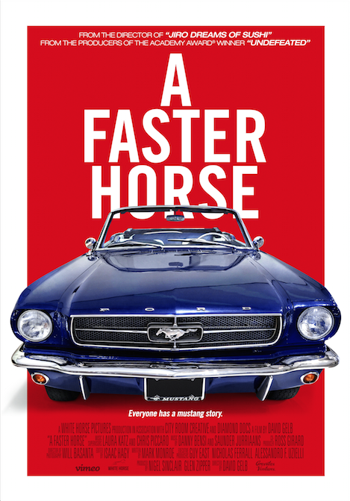

Directed by David Gelb

A White Horse Pictures Production
NEW YORK, August 31, 2015 – On the heels of a successful premiere at the 2015 Tribeca Film Festival, A FASTER HORSE will be available exclusively online on Vimeo On Demand beginning October 9th, 2015. The film is available for pre-order today, August 31 (https://vimeo.com/ondemand/afasterhorse).

Vimeo has partnered with TheatriCast, a new demand-driven distribution and marketing initiative between ticketing company Tugg and film marketing agency Different Drummer, to release A FASTER HORSE in theaters for an exclusive one-night event on Thursday, October 8th. The special event will take place in 40+ markets and provide early access to auto and Mustang enthusiasts across the country. Following the TheatriCast release, fans across the country will be able to bring the film to their local theater with Tugg.

Director David Gelb (Jiro Dreams of Sushi) tackles another venerable, beloved, and long-standing institution: the Mustang, crown jewel of the Ford fleet. As the fiftieth anniversary of the Mustang approaches and the US car industry is just emerging from the ravages of the Great Recession, Ford launches what is only its fifth redesign of the iconic Mustang since its debut in 1964. Now the expectations of thousands of Mustang devotees around the globe are all placed squarely on the shoulders of the Mustang engineering and design team. Chief Program Engineer Dave Pericak leads the charge from assembly floor to showroom - refining every minute detail - as the 2015 Mustang is put to the test in the final days leading up to its internationally anticipated launch.
Produced by Grammy Award winning Nigel Sinclair (Foo Fighters: Back and Forth) and Glen Zipper, producer of the Academy Award winning Undefeated, A FASTER HORSE is masterfully crafted with gorgeous cinematography throughout. The dynamic and celebratory film wonders aloud how an American icon can be adapted for changing times. Written by Mark Monroe (Academy Award winning The Cove), Gelb cuts in a rigorous, high-energy look at the history of Ford and the emotional connection many have to the definitive muscle car—a chassis cool enough for Steve McQueen—moving the film beyond a car lover’s documentary to a resonant examination of American ingenuity, workmanship, and resilience.
Executive producers of A FASTER HORSE are White Horse Pictures’ Guy East and Nicholas Ferrall alongside Alessandro F. Uzielli.
90 Mins / Not Rated
Director: David Gelb
Screenwriter: Mark Monroe
Producer: Nigel Sinclair, Glen Zipper
Editor: Isaac Hagy
Cinematographer: Will Basanta
Executive Producer: Guy East, Nicholas Ferrall, Alessandro F. Uzielli
Composer: Danny Bensi, Saunder Jurriaans
Co-Producer: Ross Girard
https://www.facebook.com/FasterHorseFilm
https://twitter.com/fasterhorsefilm
https://instagram.com/fasterhorsefilm
ABOUT VIMEO
Vimeo® is the high-quality online video platform, inspiring the world to share and discover videos worth watching. Vimeo provides creators of all levels professional quality tools to share, publish or sell video — with no interruptive advertising. Vimeo has over 35 million registered members and a global monthly audience of over 160 million people, making it the largest, open transactional VOD platform worldwide. Founded in 2004 and based in New York City, Vimeo, LLC is an operating business of IAC (NASDAQ: IACI).

ABOUT WHITE HORSE PICTURES

White Horse Pictures is a production company focused on high quality, commercial content creation across various different media – Film, TV, Documentaries and Digital. Based in Los Angeles, the company is built on the foundation of Nigel Sinclair and Guy East’s vast experience of producing independent movies under their previous partnerships at Intermedia and Exclusive Media. Credits include The Woman in Black with Daniel Radcliffe, Snitch with Dwayne Johnson, End of Watch with Jake Gyllenhaal, Rush with Ron Howard and Chris Hemsworth, The Ides of March with George Clooney, Terminator 3: Rise of the Machines, Sliding Doors, The Wedding Planner, K-Pax and The Life of David Gale.

Next on White Horse Pictures’ slate is the Untitled Beatles Documentary currently in post-production and the newly announced feature film Emperor. The fully authorized Beatles Documentary is directed by Academy Award-winning director Ron Howard and produced with the full cooperation of Paul McCartney, Ringo Starr, Yoko Ono Lennon and Olivia Harrison. White Horse’s Grammy Award-winning Nigel Sinclair, Scott Pascucci and Academy Award-winner and multiple nominee Brian Grazer of Imagine Entertainment are producing the film for Apple with Howard.

Emperor is being produced with Lionsgate’s Summit and is a dramatic coming of age tale set in a world of passion, power and palace intrigue at the height of the Roman Empire. The film is produced by Nigel Sinclair, and the producers of 300 and 300: Rise of an Empire: Gianni Nunnari and Mark Canton. Matt Jackson also produces.

ABOUT THEATRICAST
TheatriCast is a single night, eventized theatrical and semi-theatrical release platform that intensifies audiences around can’t-miss cinema experiences. Blending the proven unconventional marketing and publicity strategies of Different Drummer with the demand and data-driven exhibition of Tugg, TheatriCast is uniquely positioned as a valuable partner for content-creators looking to eventize, socialize, and monetize an audience. www.theatricast.com

To request a screener or schedule an interview, please contact:
Sylvia Desrochers | Suzie Cornell
Big Time PR & Marketing
Sylvia@bigtime-pr.com | Suzie@bigtime-pr.com
424-208-3496

