MICHAEL APTED’S BENDING THE LIGHT PREMIERES EXCLUSIVELY ON VIMEO ON DEMAND

Vimeo and Canon U.S.A., Inc. have partnered to debut Apted’s documentary that features the devoted artisans who shape and create lenses as well as the passionate photographers who rely on them to create their art

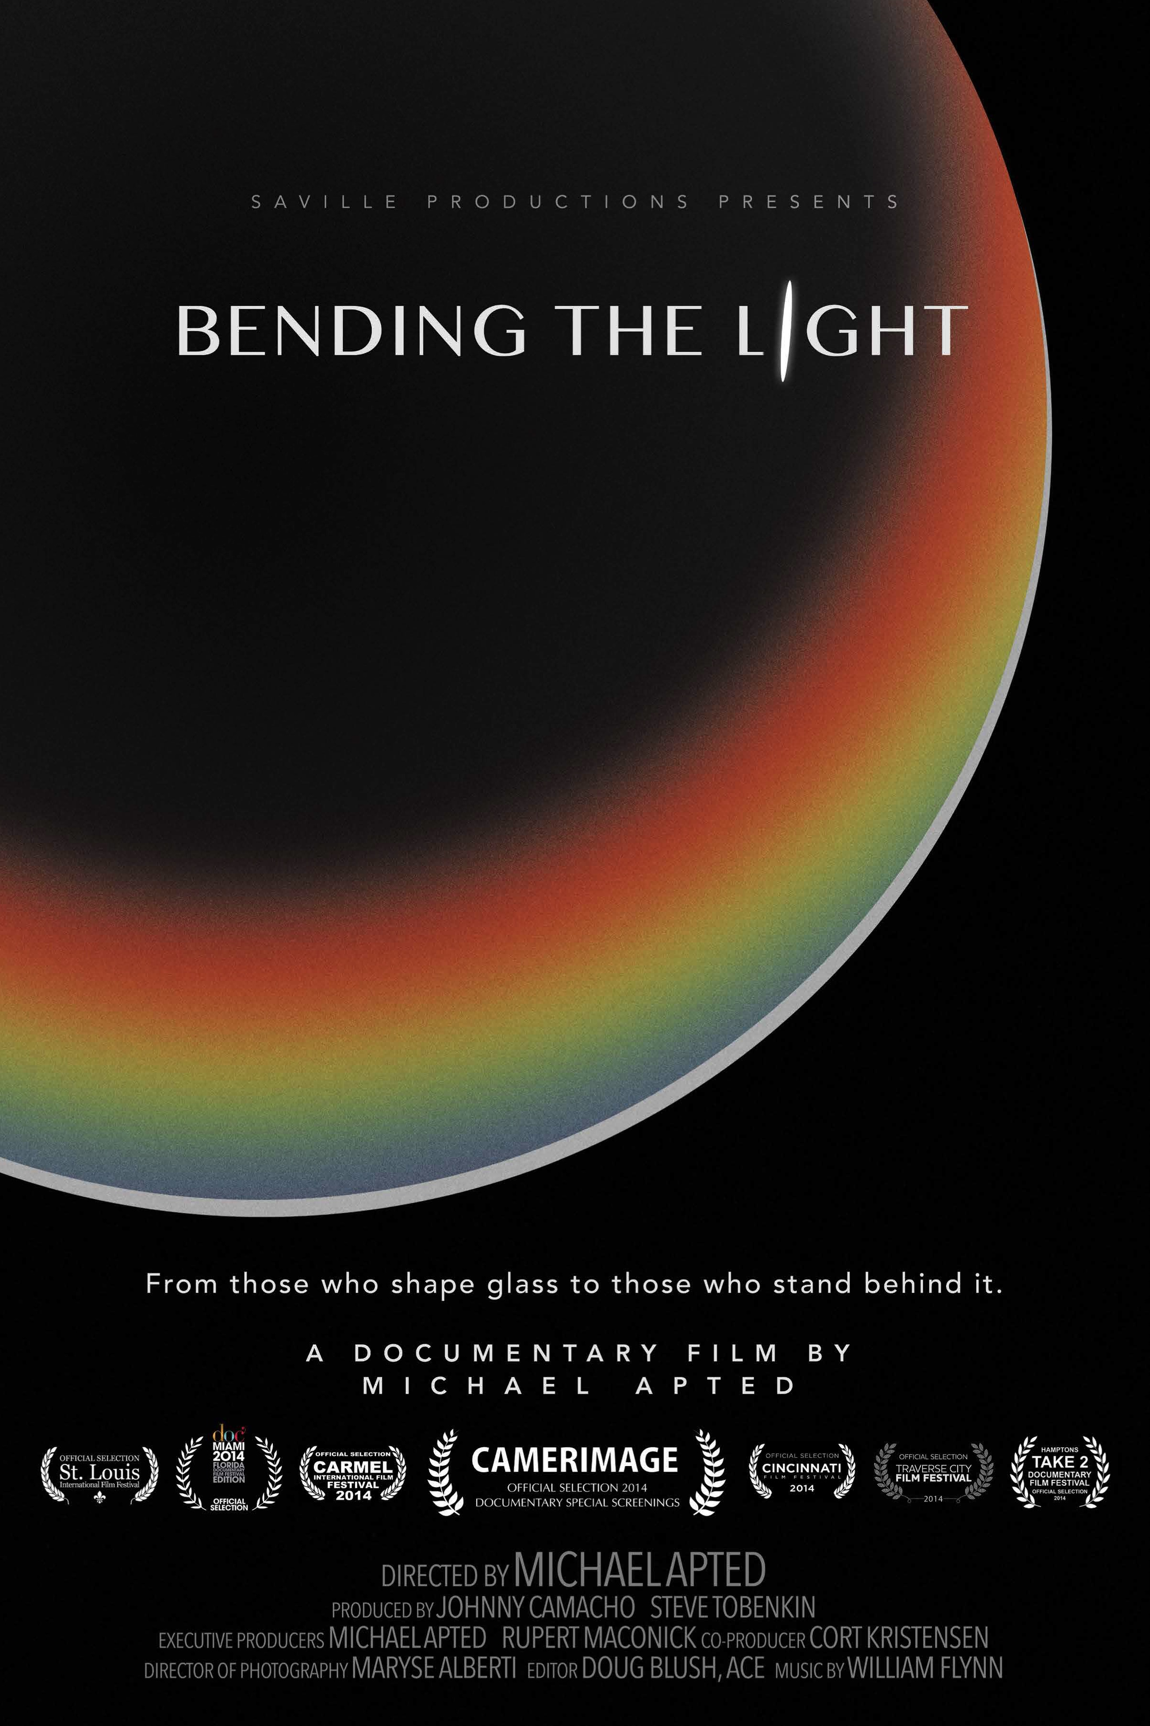

NEW YORK (May 5, 2015) – Vimeo is partnering with Canon U.S.A., Inc. to release the feature-length documentary Bending the Light, directed by veteran filmmaker Michael Apted (the Up Series, Gorillas in the Mist, The World is Not Enough). Bending the Light, a celebration of the craft of visual imaging, explores the relationship between the artisans who create camera lenses and the professionals who depend on their lenses to capture their creative visions. Bending the Light is now available globally in streaming 4K and HD at Vimeo.com/OnDemand/BendingTheLight.

Bending the Light features never-before-seen footage from inside Canon Inc.’s lens factory in Utsunomiya, Japan, intimate interviews with lens engineers, and a peek into the world of award-winning photographers and cinematographers Stephen Goldblatt, BSC, ASC, Greg Gorman, Simon Bruty, Laura El-Tantawy, and Richard Barnes.

“Bending the Light is a movie that speaks to Vimeo’s core community of creators,” said Sam Toles, Vice President, Content Acquisitions and Business Development, Vimeo. “Michael Apted’s compelling documentary gives life to the lenses and glass that make all the films we enjoy so beautiful.”

“My hope for this film was to show the connection between Canon Japanese lens makers and a handful of talented professional photographers; at a glance, seemingly disparate entities, but both artisans in their own right. Bending the Light is not a technical story, it’s one about the humanity behind every image,” said Apted. “I’m thrilled a global audience will be able to reflect on the artistry of this powerful visual medium.”

“Michael Apted has created a very moving and inspiring documentary showcasing the passion and dedication of lens makers who devote their life’s work to creating the high quality optics professional image makers rely on every day,” said Yuichi Ishizuka, president and COO, Canon U.S.A., Inc. “We are thrilled that this story can now be shared around the world.”

Bending the Light will retail on Vimeo on Demand for $4.99 for a 48-hour streaming rental or $12.99 for download to own.

For more information and to order Bending the Light, visit: Vimeo.com/OnDemand/BendingTheLight.

About Vimeo
Vimeo® is the high-quality online video platform, inspiring the world to share and discover videos worth watching. Vimeo provides creators of all levels professional quality tools to share, publish or sell video — with no interruptive advertising. Vimeo has over 35 million registered members and a global monthly audience of over 160 million people, making it the largest, open transactional VOD platform worldwide. Founded in 2004 and based in New York City, Vimeo, LLC is an operating business of IAC (NASDAQ: IACI).

About Canon U.S.A., Inc.
Canon U.S.A., Inc., is a leading provider of consumer, business-to-business, and industrial digital imaging solutions to the United States and to Latin America and the Caribbean (excluding Mexico) markets. With approximately $31 billion in global revenue, its parent company, Canon Inc. (NYSE:CAJ), ranks third overall in U.S. patents granted in 2014† and is one of Fortune Magazine's World's Most Admired Companies in 2015. In 2014, Canon U.S.A. has received the PCMag.com Readers' Choice Award for Service and Reliability in the digital camera and printer categories for the 11th consecutive year. Canon U.S.A. is committed to the highest level of customer satisfaction and loyalty, providing 100 percent U.S.-based consumer service and support for all of the products it distributes. Canon U.S.A. is dedicated to its Kyosei philosophy of social and environmental responsibility. In 2014, the Canon Americas Headquarters secured LEED® Gold certification, a recognition for the design, construction, operations and maintenance of high-performance green buildings. To keep apprised of the latest news from Canon U.S.A., sign up for the Company's RSS news feed by visiting www.usa.canon.com/rss and follow us on Twitter @CanonUSA.

† Based on weekly patent counts issued by United States Patent and Trademark Office.

All referenced product names, and other marks, are trademarks of their respective owners.

###

MEDIA CONTACTS
For Vimeo:
Jessica Casano-Antonellis | Jessica@vimeo.com | 212.524.7164
Kevin Turner | KevinT@vimeo.com |212.524.7123

For Canon U.S.A., Inc and Bending the Light:
Leigh Nofi |lnofi@cusa.canon.com |631-330-3783
Lauren Asher | asher@sunshinesachs.com | 323.822.9300
Catie Disabato | disabato@sunshinesachs.com | 323.822.9300

