BILL PLYMPTON’S ANIMATED FEATURE ‘CHEATIN’ TO PREMIERE
ON VIMEO APRIL 21st 2015
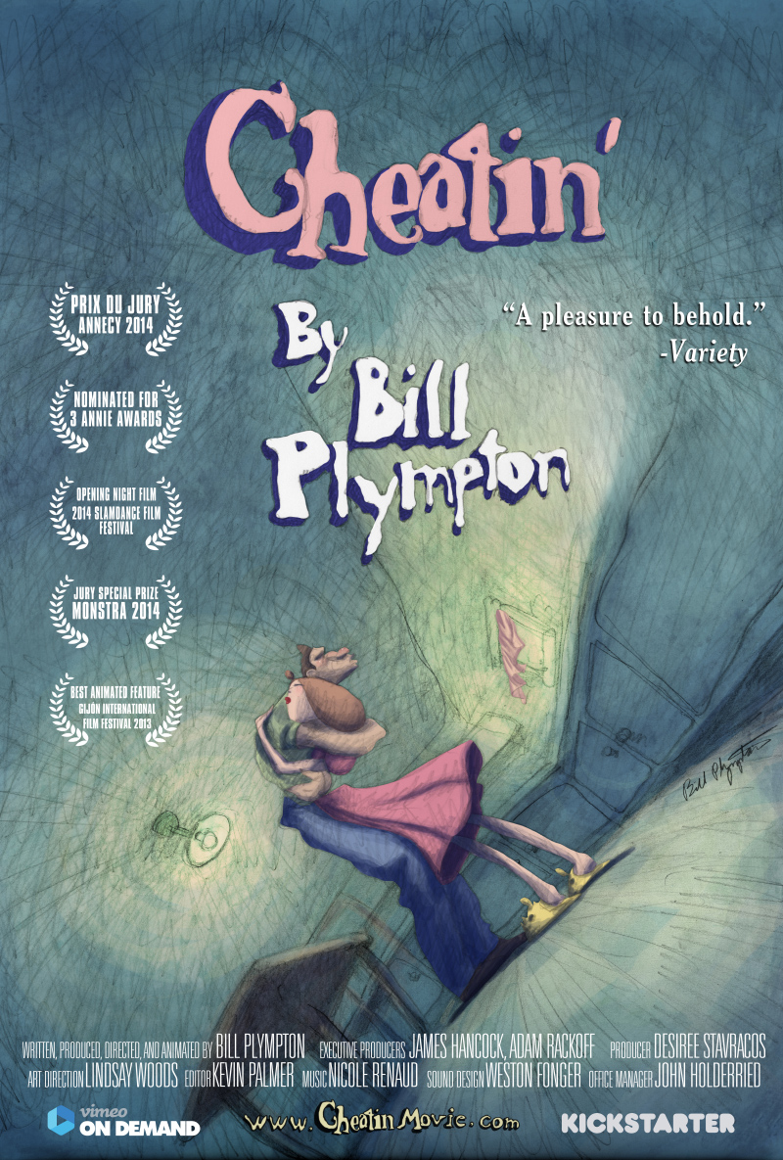

“Strife and sexual humor reign in this energetic romp, one of Bill Plympton’s best longform animated works.” – Variety

NEW YORK, March 24, 2015 – Vimeo has teamed up with the “King of Indie Animation,” Bill Plympton, for the global release of his animated feature, CHEATIN’. On the heels of a multi-city US theatrical release beginning in April, Vimeo will be releasing the film exclusively on Vimeo On Demand on April 21, 2015.

Available today for pre-order, CHEATIN' is an award-winning, surreal animated adult tale of love, jealousy, revenge, and murder. Inspired by the work of James M. Cain (“Double Indemnity”, “The Postman Always Rings Twice”), CHEATIN' marks Academy Award®-nominated Bill Plympton’s seventh animated feature film.

CHEATIN’ synopsis: In a fateful bumper car collision, Jake and Ella meet and become the most loving couple in the long history of Romance. But when a scheming “other” woman drives a wedge of jealousy into their perfect courtship, insecurity spells out an untimely fate. With only the help of a disgraced magician and his forbidden “soul machine,” Ella takes the form of Jake's numerous lovers, desperately fighting through malfunction and deceit as they try to reclaim their destiny.

Cheatin’ will retail on Vimeo On Demand for $4.99 for a 72-hour streaming rental or $9.99 for download to own.

Vimeo On Demand: https://vimeo.com/ondemand/cheatin

Poster: https://www.dropbox.com/s/xm0k9zwhqhbtrkv/poster2.jpg?dl=0

WEBSITE/Press Materials: http://cheatinmovie.com/

Running Time: 76 minutes/ Feature Film, Color, USA

ABOUT VIMEO
Vimeo® is the high-quality video platform for creators and their audiences. Vimeo’s mission is to empower and inspire people around the world to create, share, and discover videos. Vimeo enables creators to sell original films and series worldwide through Vimeo On Demand, its open self-distribution platform. Vimeo has more than 30 million registered members and reaches a global monthly audience of over 170 million people. Founded in 2004 and based in New York City, Vimeo, LLC is an operating business of IAC (NASDAQ: IACI).

Contacts:

For Vimeo:
Jessica Casano-Antonellis
Jessica@vimeo.com

