NED RIFLE
Theatrical and Vimeo On Demand release April 1, 2015
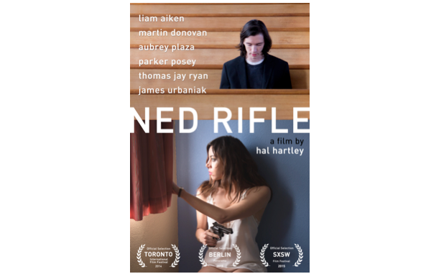
Directed by Hal Hartley

Starring Liam Aiken, Martin Donovan, Aubrey Plaza, Parker Posey,
Thomas Jay Ryan and James Urbaniak
NEW YORK, March 13, 2015 - Hal Hartley’s NED RIFLE will screen today at the SXSW Film Festival as a “Festival Favorite” in the Vimeo Theater and will be followed by a theatrical and Vimeo On Demand exclusive release on April 1, 2015: https://vimeo.com/ondemand/nedrifle.
Available today in pre-order on Vimeo, NED RIFLE is the third and final chapter of Hartley's tragicomic epic, which began with Henry Fool (1998) and continued with Fay Grim (2007). At once a saga concerning the Grim family of Woodside Queens and how their lives are turned upside down by the arrival of the self-proclaimed genius, Henry Fool (Thomas Jay Ryan), the trilogy is also an illustration of America's grappling with ideas, art, politics, and religion over the course of twenty years. In this swiftly paced and expansive conclusion, Henry and Fay's (Parker Posey) son, Ned (Liam Aiken), sets out to find and kill his father for destroying his mother's life. But his aims are frustrated by the troublesome, sexy, and hilarious Susan (Aubrey Plaza), whose connection to Henry predates even his arrival in the lives of the Grim family. A funny, sad, and seductive adventure, Ned Rifle is an intellectually stimulating and compassionate satire.
NED RIFLE is written and directed by Hal Hartley and stars Liam Aiken, Martin Donovan, Aubrey Plaza, Parker Posey, Thomas Jay Ryan and James Urbaniak. Produced by Hal Hartley and Matthew Myers with Possible Films, LLC. Cinematographer Vladimir Subotic, editor Kyle Gilman, sound by Patrick Southern and Tom Paul, production design by Richard Sylvarnes and music by Hal Hartley.
NED RIFLE will open day-and-date in NYC (IFC Center) and on Vimeo On Demand on April 1st. The film will open in LA (CineFamily), San Francisco (The Roxie), and Toronto (The Royal) on Friday, April 3. It will also open in Boston/Cambridge (The Brattle), Huntington, NY (Cinema Arts Center), Seattle (SIFF Center) and Portland, OR (The Laurelhurst) on Friday, April 10th.
The film has received the following accolades and will be shown at many international film festivals throughout 2015:
- Official Selection, SXSW Film Festival 2015
- Official Selection, Berlin Film Festival 2015
- Panorama Prize Winner, Ecumenical Jury 2015
- Official Selection, SXSW Film Festival 2015

NED RIFLE will retail on Vimeo On Demand for $4.95 for a 24-hour streaming rental or $19.95 for download to own. The soundtrack will go live on all DSP (online purchasing platforms) on March 31.
ABOUT VIMEO
Vimeo® is the high-quality video platform for creators and their audiences. Vimeo’s mission is to empower and inspire people around the world to create, share, and discover videos. Vimeo enables creators to sell original films and series worldwide through Vimeo On Demand, its open self-distribution platform. Vimeo has more than 30 million registered members and reaches a global monthly audience of over 170 million people. Founded in 2004 and based in New York City, Vimeo, LLC is an operating business of IAC (NASDAQ: IACI).

Filmmaker Hal Hartley, Aubrey Plaza, Liam Aiken and Thomas Jay Ryan and
James Urbaniak are available for select interviews

To request a screener or schedule an interview, please contact:

BIG TIME PR & MARKETING
Sylvia Desrochers | Suzie Cornell
sylvia@bigtime-pr.com | suzie@bigtime-pr.com
Office: 424-208-3496

