HISTORY MAKING “MICHAEL JACKSON: THE IMMORTAL WORLD TOUR” DOCUMENTARY BEING LAUNCHED BY CIRQUE DU SOLEIL EXCLUSIVELY ON VIMEO
Four Continents, 27 Countries, 157 Cities, 500 Shows & NOW on Vimeo On Demand
“A Thriller of a Show!” - USA Today

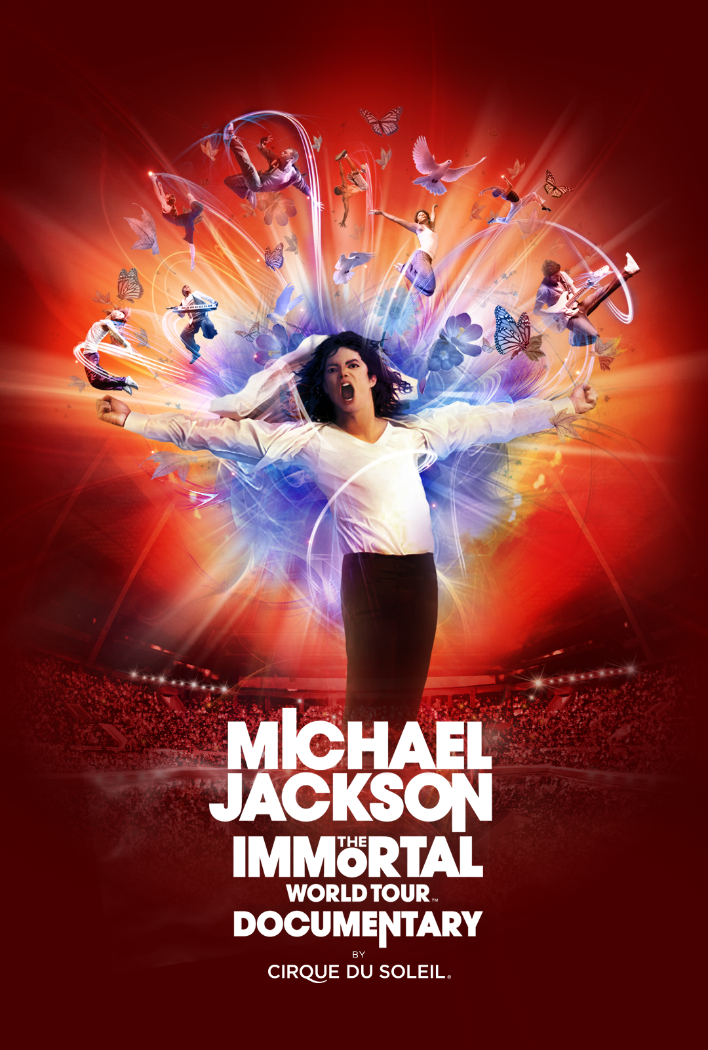

NEW YORK, March 11, 2015 – After ranking as one of the highest grossing tours in history, Michael Jackson THE IMMORTAL World Tour™– Documentary launches globally on Vimeo On Demand: vimeo.com/ondemand/MichaelJacksonImmortal.

Created by Cirque du Soleil and the Estate of Michael Jackson and directed by Jamie King, the leading concert director in pop music today, THE IMMORTAL World Tour combined the excitement and innovation of Michael Jackson’s music and choreography with Cirque du Soleil’s unparalleled creativity. USA Today called it “A thriller of a show!” The stylistic documentary showcases the creation of Cirque’s world-famous live touring show, and features more than 20 minutes of performance footage.

Cirque du Soleil collaborator and film director Adrian Wills (All Together Now, Corteo, Through the Curtain, Touch the Sky) incorporates rare archival Michael Jackson footage, early family photos and videos obtained through his Estate, interviews with those close to Michael, including some of Michael’s family, as well as the show musicians, dancers, choreographers and costume designers into the documentary.

Aimed at lifelong fans as well as those experiencing Michael’s creative genius for the first time, the show captures the essence, soul and inspiration of the King of Pop, celebrating a legacy that continues to transcend generations.

The Immortal World Tour ranks as one of the highest grossing shows in history with over $371M in revenue with ticket sales of 3.7 million from 141 cities in 27 countries.

The film is available today worldwide (except United Kingdom), for a $9.99 rental exclusively on Vimeo. Viewers can also access subtitles available in German, Brazilian Portuguese, Spanish and Japanese, along with a French dubbed version of the film.

ABOUT VIMEO
Vimeo® is the high-quality video platform for creators and their audiences. Vimeo’s mission is to empower and inspire people around the world to create, share, and discover videos. Vimeo enables creators to sell original films and series worldwide through Vimeo On Demand, its open self-distribution platform. Vimeo has more than 30 million registered members and reaches a global monthly audience of over 170 million people. Founded in 2004 and based in New York City, Vimeo, LLC is an operating business of IAC (NASDAQ: IACI).

ABOUT CIRQUE DU SOLEIL
The Cirque du Soleil Group is a Quebec-based organization providing high-quality artistic entertainment. The company and its divisions is a creative content provider for a wide variety of unique projects. In addition to shows, the company, which has its International Headquarters in Montreal, extends its creative talent to other spheres of activity. While maintaining stringent standards of artistic quality and originality, Cirque du Soleil brings to innovative projects the same energy and spirit that characterize each of its shows.

Cirque du Soleil Since its beginnings in 1984, close to 150 million spectators in over 300 cities on six continents have been thrilled by Cirque du Soleil.

Contacts:

For Vimeo:
Jessica Casano-Antonellis
Jessica@vimeo.com

For Cirque du Soleil:
Renée-Claude Ménard
rcm@cirquedusoleil.com

