Vimeo Unveils 2015 Oscar® Nominated Shorts Collection

Oscar® Nominated Documentary Shorts “La Parka” and “White Earth” Exclusively Available On Vimeo

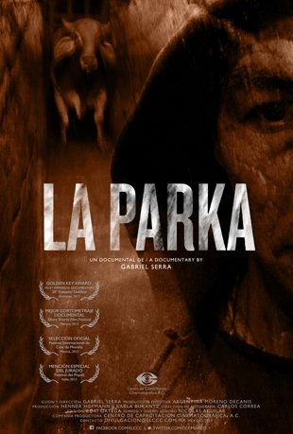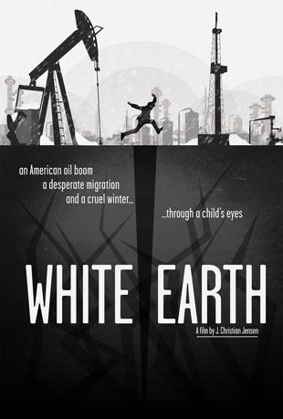

NEW YORK, February 18th, 2015 – In anticipation of the 87th Annual Academy Awards on February 22nd, Vimeo released today a collection of 2015 Oscar® nominated live-action, animation and documentary shorts on VOD: https://vimeo.com/ondemand/discover/oscars2015. The collection includes two titles from the “Documentary Short Films” category – “The Reaper/La Parka” and “White Earth” – available exclusively for a one month run on Vimeo.

The 2015 Oscar® Nominated Shorts Collection includes the following Live-Action and Animation compilations; each available globally for $3.95 streaming rental/$7.99 download respectively. Viewers who purchase the Animation compilation will also receive a selection of four highly commended bonus animation shorts.

2015 Oscar® Nominated Short Films: Live-Action:
https://vimeo.com/ondemand/shortsliveaction
- “Aya,” Oded Binnun and Mihal Brezis
- “Boogaloo and Graham,” Michael Lennox and Ronan Blaney
- “Butter Lamp,” Hu Wei and Julien Feret
- “Parvaneh,” Talkhon Hamzavi and Stefan Eichenberger
- “The Phone Call,” Mat Kirkby and James Lucas

2015 Oscar® Nominated Short Films: Animation: https://vimeo.com/ondemand/shortsanimation
- “The Bigger Picture,” Daisy Jacobs and Christopher Hees
- "The Dam Keeper,” Robert Kondo and Dice Tsutsumi
- “Me and My Moulton,” Torill Kove
- “A Single Life,” Joris Oprins

Viewers can purchase the following Oscar® Nominated Documentary Short Films, sold individually with both streaming rental and download options. The
- “The Reaper/La Parka,” Gabriel Serra Argüello: https://vimeo.com/ondemand/thereaper
- “White Earth,” J. Christian Jensen: https://vimeo.com/ondemand/whiteearth
- “Joanna,” Aneta Kopacz: https://vimeo.com/ondemand/joannadocmovie

“The Reaper/La Parka” and “White Earth” will be available exclusively on Vimeo through March 25, 2015.

ABOUT VIMEO
Vimeo® is the high-quality video platform for creators and their audiences. Vimeo’s mission is to empower and inspire people around the world to create, share, and discover videos. Vimeo enables creators to sell original films and series worldwide through Vimeo On Demand, its open self-distribution platform. Vimeo has more than 30 million registered members and reaches a global monthly audience of over 170 million people. Founded in 2004 and based in New York City, Vimeo, LLC is an operating business of IAC (NASDAQ: IACI).

About ShortsHD
ShortsHD™ is the first high definition channel dedicated to short movies and is available on DIRECTV (Channel 573), and AT&T U-Verse (Channel 1789), US Sonet (Channel 292), CenturyLink prism (1789) and Frontier Communications (Channel 1789). ShortsHD™ is operated by Shorts International, the world’s leading short movie entertainment company with the world’s largest movie catalogue dedicated to short movies. Shorts International also operates ShortsTV®, which is available in France, Belgium, Luxembourg, the Netherlands, Turkey, Romania and Eastern Africa. Shorts™ is the short movie on-demand service available on iTunes movie stores in 54 countries across the globe and Amazon Instant Video. The company is headquartered in London, England with an additional office in Los Angeles and is led by Carter Pilcher, Chief Executive.

Contacts:

Media Contact:
Sylvia Desrochers | Suzie Cornell
Big Time PR & Marketing
424-208-3496
Sylvia@bigtime-pr.com
Suzie@bigtime-pr.com

