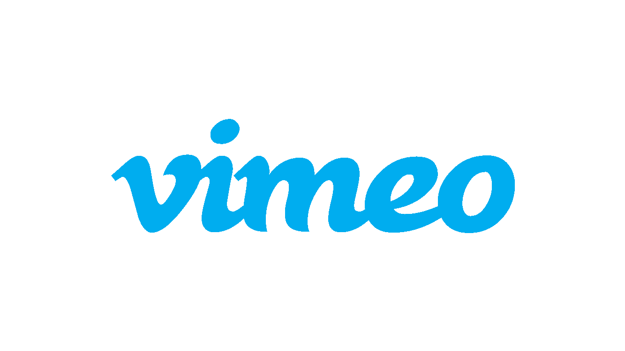
For Immediate Release

Vimeo Rings in the New Year with January Staff Pick Premieres Slate

Monia Chokri’s “Quelqu’un d’extraordinaire (An Extraordinary Person)”

January Slate Includes Dustin Guy Defa’s “Dramatic Relationships” and SXSW Grand Jury Prize-Winner “Quelqu’un d’extraordinaire (An Extraordinary Person)”

(New York, NY | January 4, 2017) Vimeo announces their January slate of Staff Pick Premieres, a different one debuting each Wednesday; Vimeo’s popular Staff Pick channel is curated by a four-person team that highlights the best short-form content on the platform. The Staff Pick laurel emblazons each selected short, which has often screened at a high profile film festival, and the short can get between 50,000 and 200,000 views in one day.

This month’s roster includes Dustin Guy Defa’s “Dramatic Relationships” and SXSW Grand Jury Prize-winner “Quelqu’un d’extraordinaire (An Extraordinary Person),” amongst other amazing titles.

Staff Pick Premieres are weekly global online premieres of a pre-selected Staff Pick. Vimeo supports each Staff Pick Premiere via on and off-site promotion, including editorial coverage and marketing support. In addition, Staff Pick Premieres have an open submission process for any film that has played at an Oscar-qualifying event within the last 24 months.

January 4th: “Sonámbulo (The Sleepwalker)” – Animation (Dir. Theodore Ushev)
Synopsis: Visual poetry in the rhythm of fantastic dreams and passionate nights, inspired by a poem from Federico García Lorca.

About the Filmmaker: Theodore Ushev developed his own original artistic style at the National Film Board of Canada. His films “The Man Who Waited” and “Tzaritza” (2006) quickly earned the respect of audiences and peers, as did his acclaimed trilogy on the relationship between art and power: “Tower Bawher” (2006), “Drux Flux” (2008) and “Gloria Victoria” (2013).

His other films include “Vertical” (2003), “Sou” (2004), “Lipsett Diaries” (2010, narrated by Xavier Dolan), “Demoni” (2012), “Nightingale in December” (2011), “Joda” (2012), “Third Page from the Sun” (2014), and “Blood Manifesto” (2014), which he animated with his own blood. His latest project, “Blind Vaysha” (2015), won more than 25 awards from major festivals (including Chicago, Annecy, Ottawa, Rio de janeire, London,) and is currently shortlisted for an Academy Award.

January 11th: “Quelqu’un d’extraordinaire (An Extraordinary Person)” – Narrative Drama, (Dir. Monia Chokri)
Synopsis: A 30-year-old scholar, intelligent and beautiful yet socially crippled, is forced to attend a bachelorette party where her quest for authenticity leads to an unavoidable confrontation with old acquaintances. Winner of the 2014 SXSW Grand Jury prize.

About the Filmmaker: As a 2005 graduate of Conservatoire d'art dramatique of Montreal, Monia Chokri first got public attention for her role in Xavier Dolan’s Les amours imaginaires. The film screened at the Cannes Festival in 2010. The following year, she starred in Dolan’s Laurence Anyways. In Quebec, she has worked in more than 20 films and television productions directed by renowned directors such as Denys Arcand, Anne Emond, Louis Choquette, Raphaël Ouellet, and André Turpin. In France, she has had roles in Claire Simon’s Gare du Nord, David Lambert’s Je suis à toi, Stéphane Foenkinos’ La trilogie du canard, and most recently in Katell Quillévéré’s Réparer les vivants. In 2017, she will appear in Morgan Simon’s first feature film as well as Robin Aubert’s Les affamés.

“Quelqu’un d’extraordinaire” screened on multiple French screens and collected more than 15 awards in Europe and in the United States. She won the Youth Jury prize in Locarno and best short film at SXSW and best short film at the Prix Jutra. In 2017, she will be directing La femme de mon frère, her very first feature film.

January 18th: “Dramatic Relationships” – Narrative Drama, (Dir. Dustin Guy Defa)
Synopsis: A male filmmaker doesn't consider his words when talking to his actresses.

About the Filmmaker: Dustin Guy Defa’s feature film Bad Fever was named one of the best films of 2012 by The New Yorker. His short film “Person to Person” (2014) premiered at the Sundance Film Festival and won awards at the Berlin International Film Festival, SXSW Film Festival, and Hot Docs. His short “Family Nightmare” also screened at the Sundance Film Festival. In 2015, the Film Society of Lincoln Center presented a weeklong retrospective of his short films. Premiering in the NEXT Section at the 2017 Sundance Film Festival is a feature adaptation of Defa’s “Person to Person” with an ensemble cast that includes Abbi Jacobson, Michael Cera, Tavi Gevinson and Philip Baker Hall.

January 25th: “Five Star” – Documentary, (Dir. Ryan Booth)
Synopsis: The story of Brandon Jones, a free safety from Nacogdoches, Texas. With more than 40 full-ride Division 1 offers, he is arguably the most sought after safety in the country. Despite his celebrity status, Brandon is still just a teenager learning how navigate his senior year of high school while facing the most difficult decision he will ever make.

About the Filmmaker: Ryan is a former audio engineer and photographer who won a short film contest sponsored by Canon and Vimeo in 2010. The final film premiered at the 2011 Sundance Film Festival and launched Ryan's career as a Director of Photography. Since then, he has shot extensively for the BBC, A&E Networks, MTV and VH1, as well as numerous commercial clients including Home Depot, Spotify, and Under Armour. He DP'd his first narrative feature, This is Where We Live, which was selected in the dramatic competition at SXSW 2013, and went on to a successful festival and theatrical run. He also created and directs a live music project, SerialBox Presents, which has garnered several million impressions and has been featured on numerous media sites including Paste Magazine and NPR. PDN recently named Ryan as one of the "20 Filmmakers to Watch in 2015." Ryan lives in Texas with his wife and two daughters and is developing his first narrative feature as director.

Honored as December’s “Best of the Month” titles are the Vimeo Original documentary Marina Abramović in Brazil: The Space In Between, Eleanor Mortimer’s Rock of Gibraltar apes versus humans doc “Territory,” Guðmundur Arnar Guðmundsson’s Icelandic tragedy “Whale Valley,” Hamy Ramezan and Rungano Nyoni’s captivating lost-in-translation drama “Listen,” Fraser Munden’s mixed media animated based-on-real-life epic “The Chaperone,” Greg&Lio’s mind bending music video “Makeba / Jain,” “Yuval Hameiri’s Sundance Jury Prize-winning documentary “I Think This is the Closest to How the Footage Looked,” Max Cooper’s trippy “Order from Chaos,” Gunner’s visually arresting animated short “Mesh,” extreme sports documentary “Ice Call,” and Truls Krane Meby’s festival favorite “World Wide Woven Bodies.”

Filmmakers interested in having their work considered for a Staff Pick premiere can email premieres@vimeo.com for more information.

About Vimeo
Vimeo is home to the world’s most imaginative video creators and the hundreds of millions of viewers who love them. Vimeo empowers over 50 million creators with the tools they need to host, share and sell videos in the highest quality possible. Also a leading online entertainment destination, Vimeo now reaches viewers in over 150 countries who can watch content anytime, on nearly every Internet-connected device. Founded in 2004 and based in New York City, Vimeo, Inc. is an operating business of IAC (NASDAQ: IAC).

Vimeo Contact
Caitlin Hughes | CaitlinH@vimeo.com

